Exploratory Data Analysis/Milestone Report

The dependent variable of interest percent_republican and the 7 independent explanatory variables have the following summary statistics:

average_age percent_republican_2012 percent_white

Min. :18.00 Min. : 5.978 Min. : 2.50

1st Qu.:37.10 1st Qu.:50.538 1st Qu.:67.65

Median :39.90 Median :60.791 Median :86.30

Mean :39.86 Mean :59.653 Mean :78.75

3rd Qu.:42.80 3rd Qu.:70.277 3rd Qu.:94.30

Max. :62.50 Max. :95.862 Max. :99.20

percent_degree percent_uninsured

Min. : 3.70 Min. : 3.10

1st Qu.:13.10 1st Qu.:14.00

Median :16.80 Median :17.70

Mean :19.01 Mean :17.99

3rd Qu.:22.60 3rd Qu.:21.50

Max. :71.00 Max. :46.00

percent_unemployed average_income percent_republican

Min. : 0.800 Min. : 0 Min. : 4.122

1st Qu.: 5.800 1st Qu.:22332 1st Qu.:54.960

Median : 7.500 Median :24825 Median :66.715

Mean : 7.706 Mean :25461 Mean :63.600

3rd Qu.: 9.300 3rd Qu.:27549 3rd Qu.:75.033

Max. :28.300 Max. :56674 Max. :95.273

Also of importance for an initial explanatory analysis is a list of the correlation coefficient between each independent explanatory variable and the dependent variable percent_republican, shown below.

#average_age 0.3325677

#percent_republican_2012 0.9347904

#percent_white 0.5365550

#percent_uninsured 0.1950089

#percent_degree -0.4936432

#percent_unemployed -0.2728920

#average_income -0.1996266

Let’s now take a closer look at our 8 varibales.

1. Percent_republican: This variable is measuring the Republican percentage of the vote in the 2016 presidential election. It appears to be roughly normally distributed with the median and mean relatively close in value(66.7% and 63.6%) respectively. The first quintile is 55.0% and the 3rd quintile is 75.0% with a min of 4.1% and a max of 95.3%.
2. Percent_republican 2012: This variable is the most strongly correlated with percent_republican with a correlation coefficient of 0.93, given that party affiliation usually doesn’t change over 4 years. Like percent_republican it is normally distributed, with the median and mean being very close in value(60.8% and 59.7%) respectively. Below is a plot showing the strong linear correlation between percent_republican 2012 and percent_republican.

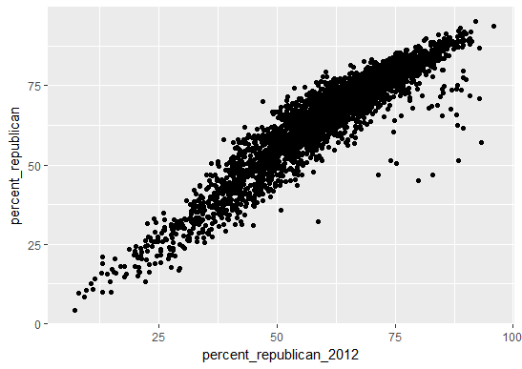

1. Percent_white: After percent_republican_2012, this is the v